
REPORT ON

NUMBER GUESSING GAME
Using python with random and maths.

In partial fulfilment of the requirement for the course.

Basics of python

Submitted by:
AZIM IRFANI
Email: themursaleenirfani@gmail.com

Under supervision of:
Uvesh Ahmad.

CENTRE FOR INNOVATION AND ENTREPRENEURSHIP
YEAR OF SUBMMISION - 2026

CANDIDATE ‘S DECLARATION-

I hereby declare that the project report titled “NUMBER GUESSING GAME” – using basics of python, submitted by AZIM IRFANI , is an original work conducted by me under the supervision of the faculty at centre for innovation entrepreneurship , jamia millia islamia , new delhi , this project has not been submitted by any other university or institution for the award of any degree or certificate.

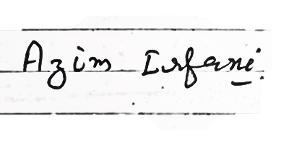
Place : new delhi online (https://jmi.entraropen.com)
Date : 01/09/2026

ACKNOWLEDGMENT

I would like to express my deep gratitude to Mr. Uvesh Ahmad, my project supervisor at Centre for Innovation and Entrepreneurship, JMI, for his valuable guidance and continuous support throughout the duration of the project. His expert advice on Python programming and GUI development greatly helped shape this NUMBER GUESSING GAME project. I also thank my peers and family members for their motivation and encouragement that helped me complete this project successfully.

AZIM IRFANI.
Place: New Delhi, Online
(https://jmi.entraropen.com)

ABSTRACTS
This project focuses on the development of an intractive text – based Number Guessing Game using python . designed to demonstrate fundamental programming concepts the applications generate a random integer within a specified range(e.g 1 to 100) using python’s built in random module . receiving real – time feedback after each attempt indicating whether their guess is “too high” or “too low”. The game tracks the number of attempts and concludes when the user successfully guesses the target number.

To ensure a robust user experience, the system incorporate structured control flow using while loops and condition statements (if-elif- else), alongside basic exception handling to
validate user inp
uts against non numeric characters. Overall , this project serves as an
practical implementation of essential computation logic , input validation , and algorithm design in python , making it an ideal demonstration of core software development
principles for entry – level applications .

TABLE OF CONTENTS

DECLARATION …………………………………………………. 2
ACKNOWLEDGMENT ……………………………………………………………… 3
ABSTRACT …………………………………………………………………………….. 4 CANDIDATE’S
PROJECT OVERVIEW & SETUP
How the Number Guessing Game Works (Flowchart & Mechanics) …. 7–8
CHAPTER 1 & 2 – INTRODUCTION AND PROBLEM STATEMENT ………. 8
CHAPTER 3 – OBJECTIVE ……………………………………………………….. 9
CHAPTER 4 & 5 – SCOPE OF THE PROJECT; TECHNOLOGY & REQUIREMENTS …………………………………………………………………… 11
CHAPTER 6 – FEASIBILITY STUDY …………………………………………… 12
CHAPTER 7 – SYSTEM DESIGN AND METHODOLOGY ……………….. 13
CHAPTER 8 – SYSTEM FLOWCHART ……………………………………….. 14
CHAPTER 9 – ALGORITHM ……………………………………………………… 15
CHAPTER 10 – PSEUDOCODE …………………………………………………. 16
CHAPTER 11 – IMPLEMENTATION / SOURCE CODE …………………. 17–19
CHAPTER 12 – DETAILED CODE EXPLANATION ………………………. 20
CHAPTER 13 – TESTING AND VALIDATION …………………………….. 21
CHAPTER 14 – SAMPLE OUTPUT AND USER EXPERIENCE ………. 22
CHAPTER 15 & 16 – ADVANTAGES AND LIMITATIONS; FUTURE SCOPE ………………………………………………………………………………….. 23
CHAPTER 17 & 18 – CONCLUSION AND REFERENCES ……………… 24
APPENDIX A & B – VIVA / PRESENTATION QUESTIONS; PROJECT SUMMARY …………………………………………………………………………….. 25–26
ANNEXURE A – FUNCTIONAL REQUIREMENTS AND SPECIFICATIONS ………………………………………………………………………… 27



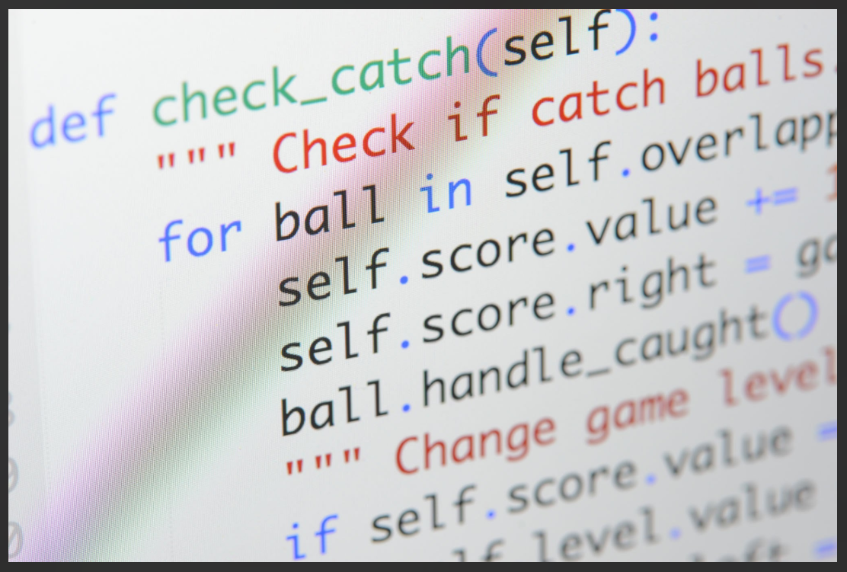
Project Overview
The Number Guessing Game is a CLI-based application where the computer generates a random integer within a specified range, and the player attempts to guess it within a limited number of attempts.
- Language: Python 3.x
- Flow: (while, if-elif-else), user input validation, exception handling,
- Modules Used: random, math
- Key Concepts: Control dynamic attempt calculation using binary search logic.
- A Number Guessing Game setup requires configuring game rules, defining difficulty levels, and initializing tracking variables.

Project Setup Structure

Configuration File (config.py)
This file centralizes all configurable settings, including difficulty ranges and attempt limits.
Python:
Main Application File (main.py)
This handles user setup, input validation, number generation, and game initialization.
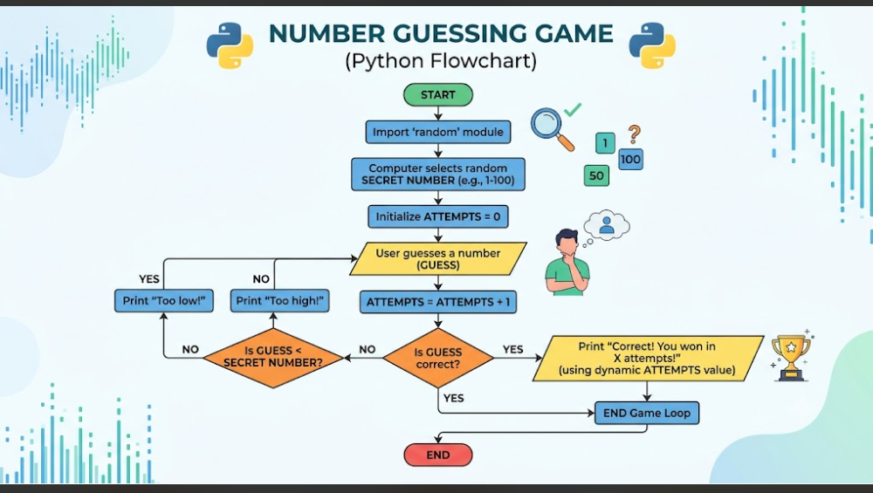

Game Mechanics:
- Core Loop: The system picks a target number (e.g., between 1 and 100). The player enters a guess, and the system compares it against the target.
- Feedback:
  - If guess < target: Output "Too Low!"
  - If guess > target: Output "Too High!"
  - If guess == target: Output success message and total attempts, then terminate.
- Attempt Tracking: A counter tracks the total valid guesses made.
- Input Validation: Non-integer inputs or out-of-bounds numbers prompt an error message without consuming a turn attempt.

CHAPTER 1 — INTRODUCTION
Python is a high-level, general-purpose programming language widely used for application development, automation, data analysis, artificial intelligence, education, and scripting. Its readable syntax makes it especially suitable for beginners learning computational thinking and programming logic.
The Number Guessing Game is a small but complete application that demonstrates how individual programming concepts can work together. Although the game is simple, it includes a clear input-process-output cycle, decision-making, repetition, validation, and a defined termination condition. These features make it an appropriate introductory college project.

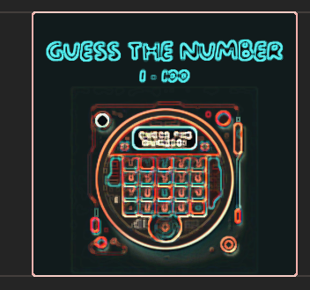
CHAPTER 2 — PROBLEM STATEMENT
A user needs an interactive program that can select a secret number and guide the user toward discovering it. The program should not reveal the secret value directly. Instead, it should compare every guess with the generated number and provide useful feedback. It must continue accepting guesses until the correct number is entered, while also preventing invalid input from causing the program to terminate unexpectedly.
The problem therefore involves random number generation, data input, comparison operations, repetition, and error handling
CHAPTER 3 — OBJECTIVES

The major objectives of this project are:
• To develop a functional number guessing game using Python.
• To use the random module for unpredictable number generation.
• To demonstrate variables and data types.
• To implement keyboard input and output messages.
• To use conditional statements for decision-making.
• To use loops for repeated guesses.
• To validate user input using exception handling.
• To count and display the number of attempts.
• To document the project using a structured software-development approach.

CHAPTER 4 — SCOPE OF THE PROJECT

The current project focuses on a single-player console-based game with a fixed range of 1 to 100. The application is designed for educational purposes and emphasizes programming fundamentals rather than advanced user-interface design.
The scope can be extended to include multiple difficulty levels, configurable ranges, maximum attempts, score calculation, player profiles, persistent high scores, graphical interfaces, sound effects, and network-based multiplayer functionality. The current version provides the foundation for such improvements.

CHAPTER 5 — TECHNOLOGY AND REQUIREMENTS

Programming language: Python 3.x Standard .
library: random .
Application type: Console / command-line.
application Development tools: IDLE, VS Code, PyCharm, or another
Python-compatible editor.
Hardware: Basic computer with keyboard and display
Operating system: Windows, Linux, or macOS

No external database or third-party package is required for the basic implementation. This makes the project easy to install, execute, and demonstrate in a classroom environment.
CHAPTER 6 — FEASIBILITY STUDY

Technical feasibility:
The application requires only Python and its standard library, so it can be developed and executed on ordinary systems.
Economic feasibility:
The project has negligible software cost because Python and many development environments are freely available.
Operational feasibility:
The game is easy to operate because it uses straightforward keyboard input and textual instructions.
Educational feasibility:
The project is highly suitable for learning because the code is compact, testable, and directly demonstrates fundamental programming concepts
CHAPTER 7 — SYSTEM DESIGN AND METHODOLOGY

The system follows an input-process-output methodology. During initialization, the application generates the secret number and sets the attempt counter to zero. During processing, the user enters a guess, the input is validated, and the value is compared with the secret number. The output stage provides feedback and, when the correct answer is entered, reports the total attempts.
The repeated guessing cycle is controlled by a loop. The loop has a clear termination condition: equality between the user guess and the secret number.
CHAPTER 8 — SYSTEM FLOWCHART
The following flowchart represents the logical sequence of the application from initialization to successful completion.
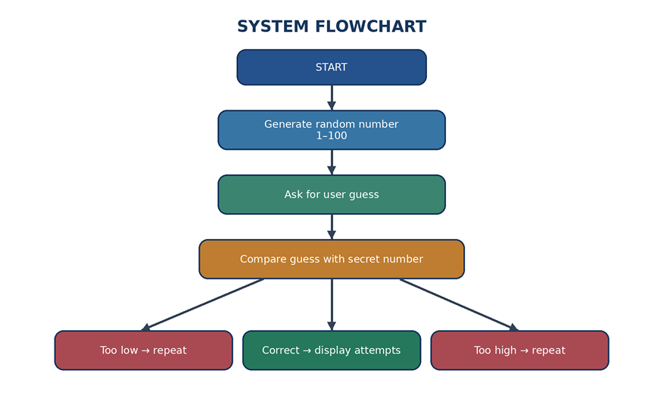

CHAPTER 9 — ALGORITHM

1. Start.
2. Import the random module.
3. Generate a random integer between 1 and 100.
4. Initialize the attempt counter to zero.
5. Display instructions to the user.
6. Ask the user to enter a guess.
7. Convert the input to an integer.
8. If conversion fails, display an error message and repeat the input step.
9. Increase the attempt counter.
10. Compare the guess with the secret number.
11. If the guess is lower, display “Too low”.
12. If the guess is higher, display “Too high”.
13. If the guess equals the secret number, display the success message and attempt count.
14. Exit the loop and stop the program.

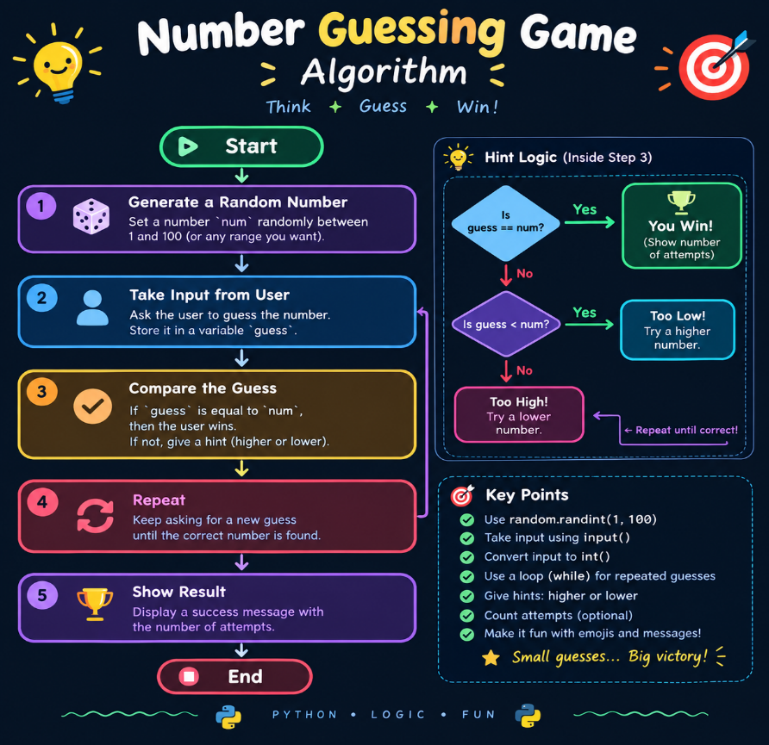
CHAPTER 10 — PSEUDOCODE

BEGIN :
Generate SECRET_NUMBER from 1 to 100 Set ATTEMPTS = 0 Display welcome message
REPEAT:
Read GUESS from user If GUESS is not a valid integer, display error Otherwise increase ATTEMPTS If GUESS < SECRET_NUMBER, display “Too low” Else if GUESS > SECRET_NUMBER, display “Too high” Else display “Correct” and ATTEMPTS
UNTIL GUESS = SECRET_NUMBER
END .

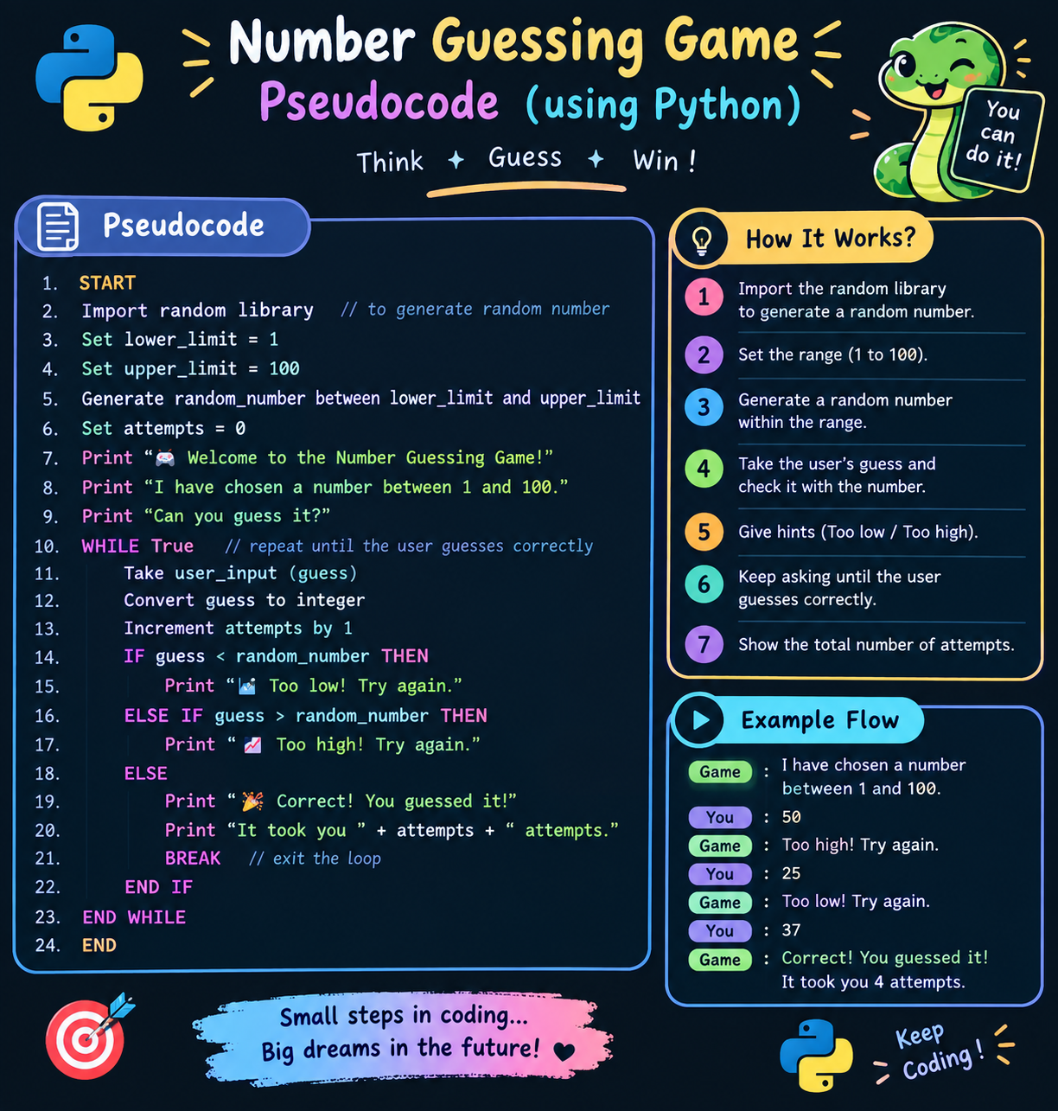
CHAPTER 11 — IMPLEMENTATION / SOURCE CODE

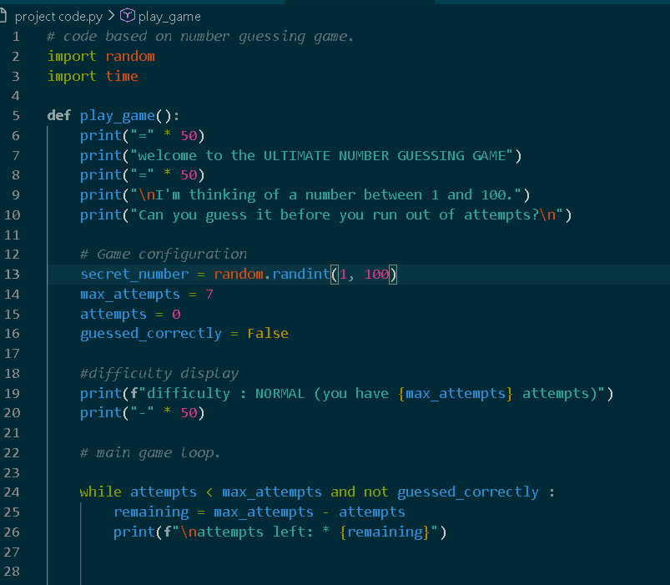
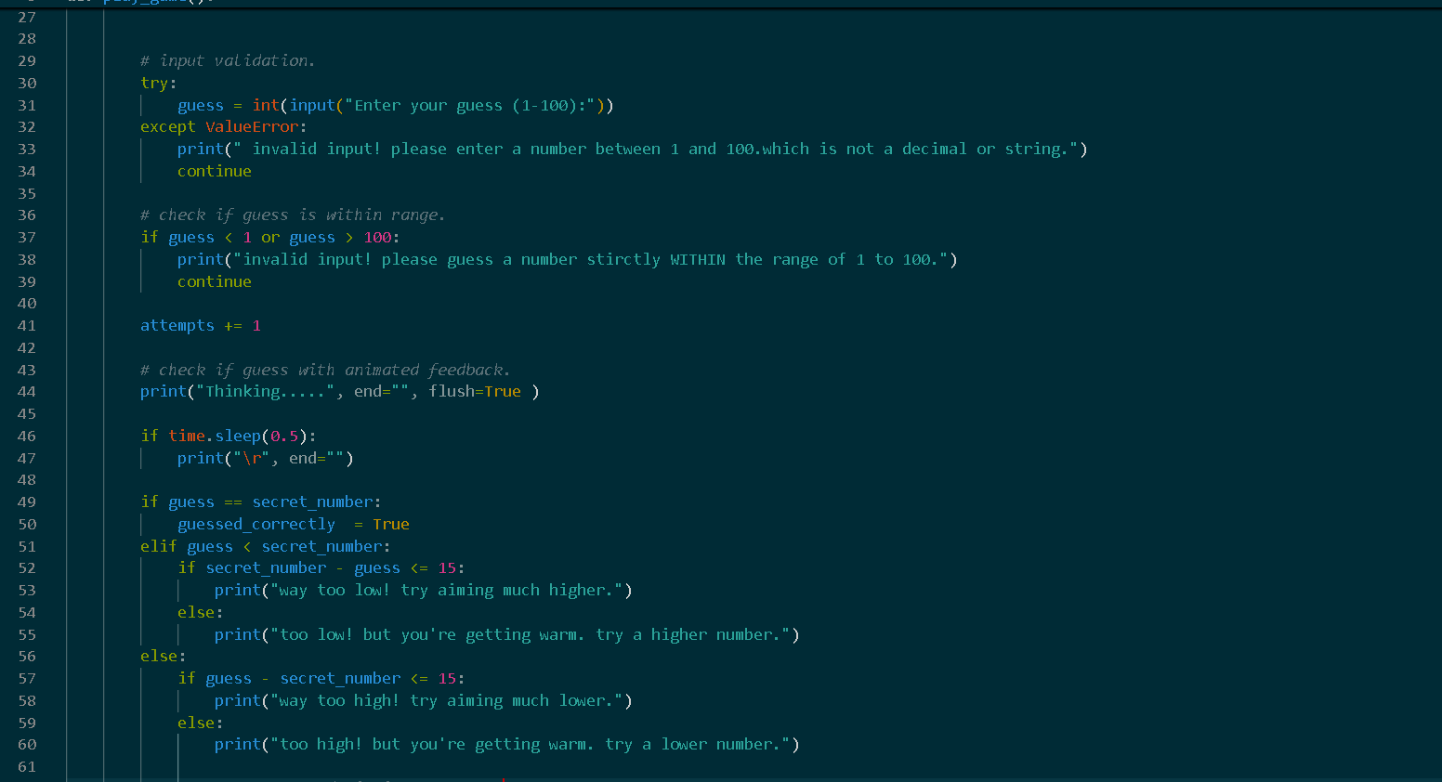
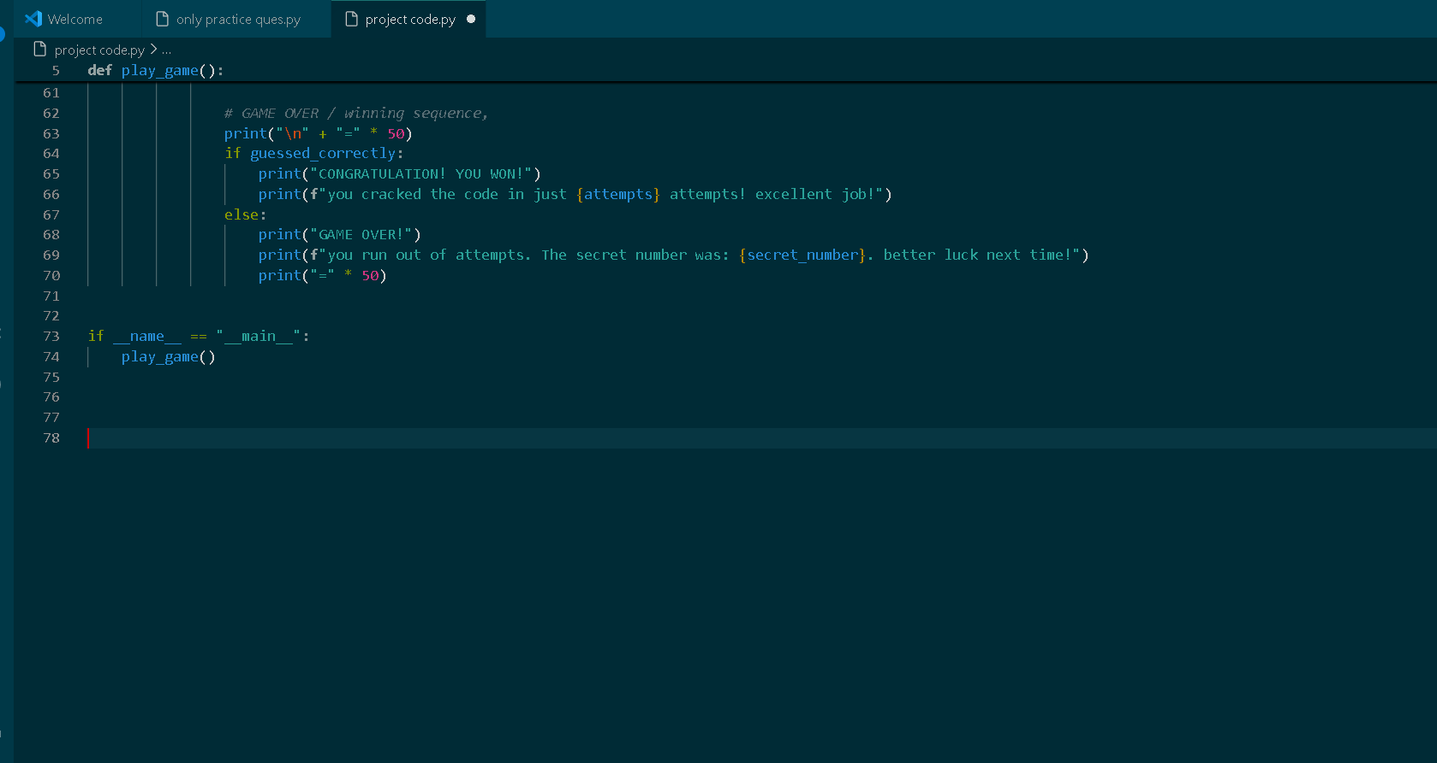
The implementation uses only the Python standard library. The try/except block ensures that non-numeric input is handled gracefully rather than causing an unhandled ValueError.
CHAPTER 12 — DETAILED CODE EXPLANATION

  - import random: Loads Python’s built-in random module.
2. random.randint(1, 100): Generates an integer in the inclusive range from 1 to 100.
3. secret_number: Stores the hidden value selected by the computer.
4. attempts: Tracks the number of valid guesses entered by the player.
5. input() and int(): Receives the keyboard entry and converts it to an integer.
6. while True: Creates a continuous guessing loop.
7. if / elif / else: Compares the guess with the secret number and selects the correct feedback.
8. try / except: Handles invalid input such as letters or symbols.
9. break: Ends the loop once the correct number has been guessed
CHAPTER 13 — TESTING AND VALIDATION
Testing was performed by considering the major logical paths of the program. Each test case checks whether the expected response is produced for a particular input condition.

Testing conclusion: The test cases cover the low-guess, high-guess, correct-guess, invalid-input, and repeated-input paths. These cases provide reasonable basic verification for the educational version of the application 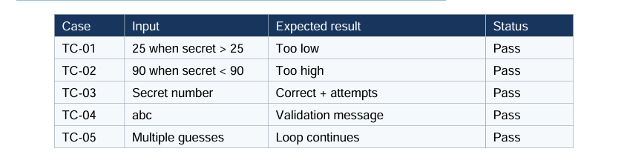
Testing conclusion: The test cases cover the low-guess, high-guess, correct-guess, invalid-input, and repeated-input paths. These cases provide reasonable basic verification for the educational version of the application .

CHAPTER 14 — SAMPLE OUTPUT AND USER EXPERIENCE
A typical execution may appear as follows:

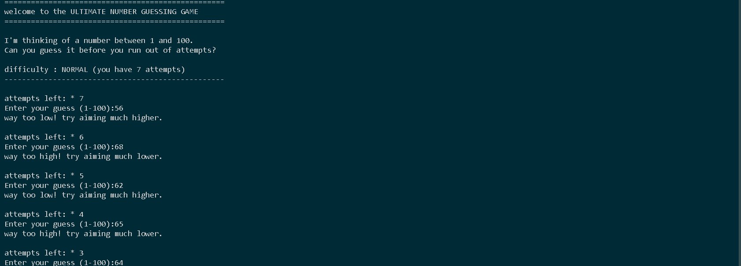
The interface is intentionally minimal. Clear messages tell the user what to enter and provide immediate feedback after every attempt. This makes the application suitable for first-time programmers and classroom demonstrations.
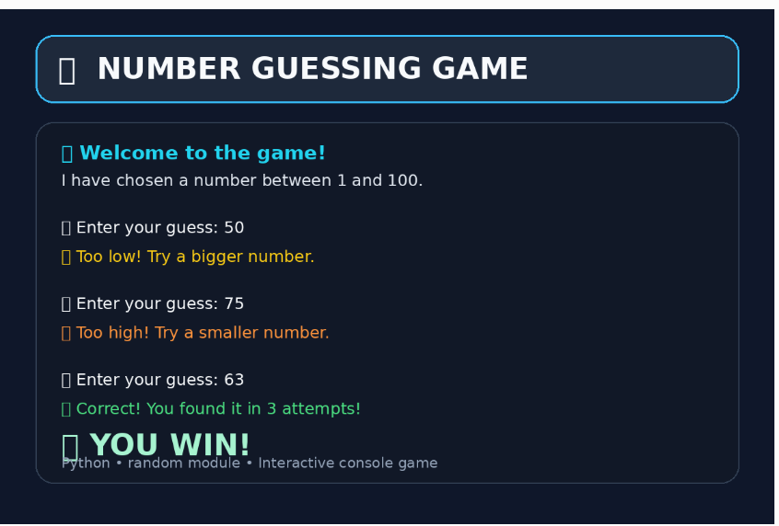

CHAPTER 15 — ADVANTAGES AND LIMITATIONS
Advantages :
• Simple and easy-to-use interface.
• Requires minimal computing resources.
• Demonstrates multiple core Python concepts in one project.
• Easy to test and modify.
• Uses only standard Python functionality.
Limitations:
• Console-only interface.
• Fixed range in the basic version.
• No persistent score storage.
• Single-player experience.
• No graphical or multimedia features.
CHAPTER 16 — FUTURE SCOPE
The project can be developed into a more advanced application by adding selectable difficulty levels, a configurable number range, maximum attempts, scoring rules, replay functionality, player names, a leaderboard, and persistent storage. A graphical interface can be created with Tkinter or another GUI framework. Sound effects and animations could improve engagement, while a web version could support browser-based play. A multiplayer version could also be developed using networking concepts.

CHAPTER 17 — CONCLUSION
The Number Guessing Game successfully demonstrates the complete development cycle of a small Python application. The project begins with a clearly defined problem, translates the problem into an algorithm, implements the algorithm using Python, and verifies the result through testing. The application illustrates random number generation, variables, input/output, conditions, loops, and exception handling in a practical context.
The project can therefore serve as a foundation for further study of Python programming, software design, user-interface development, and application enhancement.

CHAPTER 18 — REFERENCES
1. Python Software Foundation. Python Documentation.
2. Python Software Foundation. random — Generate pseudo-random numbers.
3. Python Software Foundation. Built-in Exceptions.
4. Introductory Python programming course notes and laboratory exercises.
5. General software engineering principles related to algorithms, testing, and documentation.
APPENDIX A — VIVA / PRESENTATION QUESTIONS
1. What is the purpose of the random module?
2. What does random.randint(1, 100) return?
3. Why is a while loop used?
4. What is the role of the attempts variable?
5. What happens if the user enters a letter?
6. Why is break used in the program?
7. What is the difference between if, elif, and else?
8. How could the project be converted into a GUI application?
9. How could a scoring system be added?
10. What test cases are necessary to verify the game?

APPENDIX B — POSSIBLE ENHANCEMENTS
Possible enhancements include:
• Difficulty modes: Easy (1–50), Medium (1–100), Hard (1–500).
• Attempt limits: End the round after a specified number of guesses.
• Scoring: Award more points for fewer attempts.
• Replay: Ask whether the player wants another round.
• GUI: Replace console prompts with windows, buttons, and labels.
• Leaderboard: Store and compare the best scores.
• Database/file storage: Preserve results between sessions.
• Multiplayer: Allow one player to set the number while another guesses.

APPENDIX C — PROJECT SUMMARY

Project Title: Number Guessing Game Using Python
Application Type: Console-based interactive program
Primary Concepts: Random numbers, variables, input/output, conditions, loops, exception handling
Input: User guesses
Output: Hints and final attempt count
Termination: Correct guess
Future Direction: GUI, scoring, persistence, and multiplayer support.

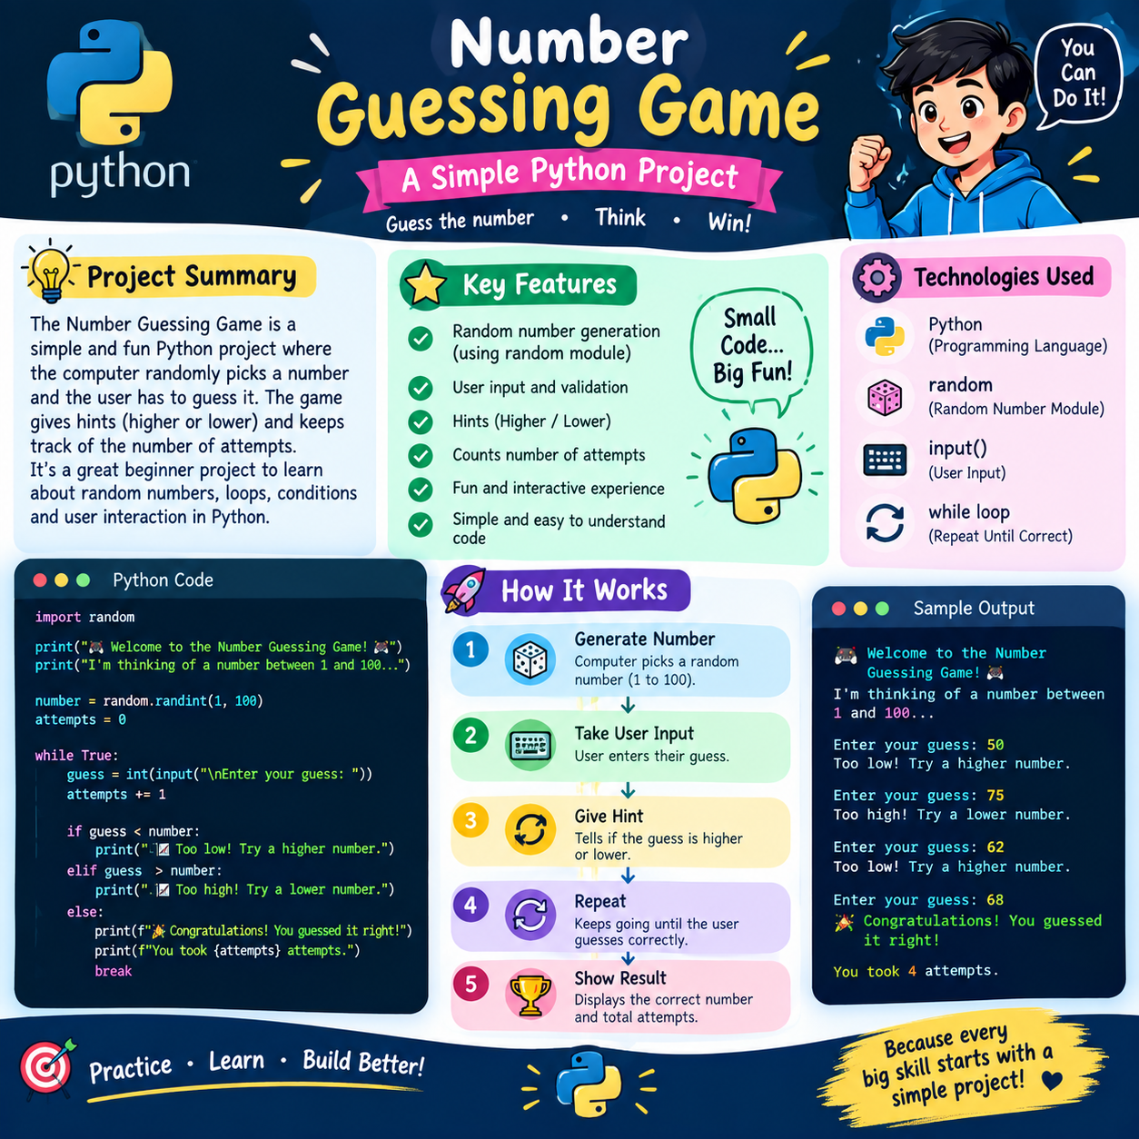
Annexure A:
Functional Requirements & Specifications
Component | Description | Logic / Condition
Random Generation | Target number selection | random.randint(lower, upper)
Max Attempts | Dynamically calculated fair limit | $$\left\lceil \log_{2}\left(\text{upper}-\text{lower}+1\right)\right\rceil$$
Feedback Loop | Hints given after every guess | Too LOW or Too HIGH based on comparison
Input Validation | Prevents program crash on bad input | try-except block handling ValueError

